

**CSE 103: Structured programming**

**Section: 5, Summer-2018**

|  |
| --- |
| A Project Report  on  **Jeroo’s Island** |
| Submitted by:  Group:  Group Members:  Mustaq Ahmed 2018-2-60-090  Navid Rahman 2018-2-60-088  MD. Sadman Islam seyam 2018-2-60-002 |
| Submitted to:  Amit Kumar Das  Senior Lecturer, Dept. of CSE |
| Date of Submission:28-08-2018 |

**DEPARTMENT OF COMPUTER SCIENCE & ENGINEERING**

**EAST WEST UNIVERSITY**

1. **Problem Statement**

Jeroo’s Island is a program that display a program named Jeroo’s movement towards a flower. For example, how Jeroo will reach to the flower following the right or left path or the upper or down way.

In this project, our task is to show Jeroo’s movement towards the flower following some certain rules and condition.

.

**2. System Requirements**

The system on which the project is implemented has the following properties:

Processor: Intel Core i5,2.56 GHz

RAM: 8.00 GB

Operating System: Windows 10, 64-bit

IDE (Integrated Development Environment): Code-Blocks

**3. System Design**

In this section, the algorithm of the project is described as below:

* 1. Input some integers and represent them as Island , Jeroo’s and the Flower location.
* 2. If the inputs of location are valid
  + - 2.1: Display Jeroo’s and Flower location.
* 3. Else
  + - 3.1: Display ‘Invalid input’.
* 4. If inputs are valid , calculate Jeroo’s movement towards the Flower.

**4. Implementation**

In this section, important parts of the source code are explained.

**4.1 Taking Input:**

An infinite *for()* loop is used to input the string multiple times. Here, *scanf*  function is used to input the integers. If user gives matrix size 0 0 as input, the *break* statement terminates the loop and the program exits.

* **Taking Input:**
* for(i=0;i<n;i++)
* { for(j=0;j<m;j++){
* if(n==0&&m==0)
* break;
* else{
* printf("Enter size of the matrix: ");
* scanf("%d %d",&n,&m);
* if(n==0&&m==0)
* break;
* char a[n][m];
* printf("Enter location of jeroos: ");
* scanf("%d %d",&x,&y);
* printf("Enter location of flower: ");
* scanf("%d %d",&p,&q);

**.**

**4.2 Movement of Jeroo**

**Part 1:**

* printf("Movement of Jeroo: \n");
* if(y<q)
* {
* for(i=y;i<q;i++)
* {
* printf("Right ");
* }
* }
* if(x<p)
* {
* for(i=x;i<p;i++)
* {
* printf("Down ");
* }

}

**Part 2:**

* if(x>p)
* {
* for(i=p;i<x;i++)
* {
* printf("Up ");
* }
* }
* printf("\n");
* }
* printf("\n");
* }

}

**5. Testing Results**

In this section, some sample input-outputs are explained with appropriate screenshot.

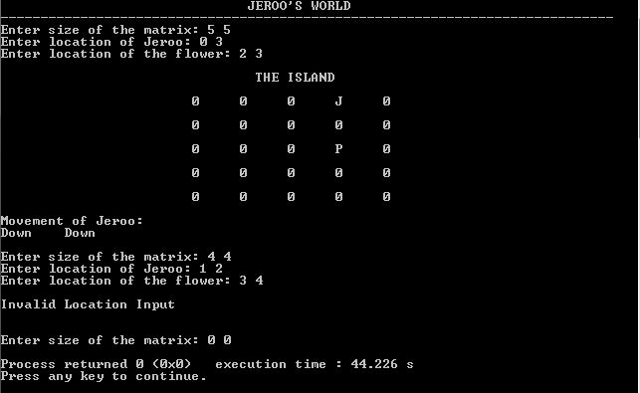

**5.1 Testcase 1:**

Here the input integers are “matrix size, Jeroo’s and flower location”.so we can see Jeroo is moving towards the flower by down and down way.

**5.2 Testcase 2:**

If Jeroo’s or the flowers location is greater than or equal to matrix size, then it will show invalid location input.

**5.3 Testcase 3:**

If the matrix size is 0 0,then the program will terminate..

**6. Future Scope**

In future, some modifications can be done so that the program can calculate Jeroo’s movement when Jeroo’s and Flower location both are same.